ALLEN ORTHOTICS AND PROSTHETICS
2502 W. Ohio Avenue 1921 E. 37th Street, Ste A
Midland, TX Odessa, TX
432-683-3788 432-332-9821

TLSO FITTING AND CARE INSTRUCTIONS

Function:
Your Thoracic, Lumbar, Sacral Orthosis (TLSO) is designed to support your spine and to aid in pain relief due to a spinal condition OR while you are healing after surgery.

Use:

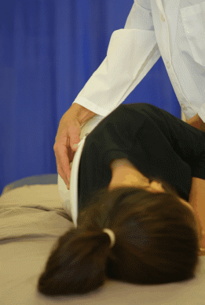
Donning your Orthosis

- To don the orthosis you will be using the “log roll” method that your physical therapist will have instructed you in performing. This method is done by rolling onto your side and having the back section placed against you as illustrated.

- The next step is to roll onto your back and make sure the sides of the orthosis are evenly positioned at your sides and make sure the inner contour fits at your waist.
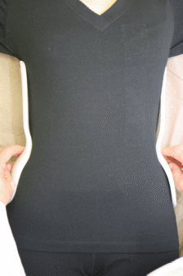
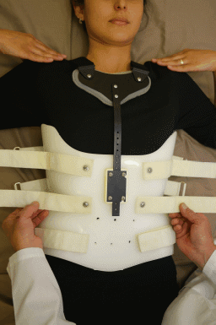
- The front section can then be placed, with the front sides OVERLAPPING the back section. Secure the straps to a snug tension. After standing make sure the straps are tight enough to keep the orthosis from shifting up or down.

- You should fasten the over-the-shoulder straps SLIGHTLY snug WHILE STANDING. They will be too tight if fastened when sitting.

Wear Schedule for Your Orthosis

You should consult your doctor on exactly when he/she would like you to wear your orthosis.

Care/Maintenance:
The plastic portion of your orthosis can be cleaned with soap and water, or rubbing alcohol. If your orthosis has foam lining this may be cleaned with rubbing alcohol as well. Allow to fully dry before re-donning your orthosis. When caring for your orthosis, do not allow the Velcro straps to become wet. The Velcro will begin to fail if it becomes to wet.

Precautions:
REMEMBER to always wear a tight, light T-shirt or tank top under your orthosis with all wrinkles smoothed out.
REMEMBER that the sides of the front section OVERLAP the back section.
REMEMBER to use the waist area as a LOCATING reference. After taking your orthosis off check for any pressure areas, or areas of redness that do not go away within 20-30 minutes. If any are noted, contact this clinic to schedule an adjustment appointment with your Orthotist.

Now that you have received the orthosis and have been instructed in the fitting and removal methods, you should refer to these instructions as needed. You should call your Orthotist with questions or concerns about the orthosis.

Report failures, malfunctions or changes in your physical condition to us as soon as possible.

